|  |  |
| --- | --- |
| NHC Ref. No. 2003146 | |
|  | |
| January 12, 2018 | |
|  | |
| **Cramer Fish Sciences** | |
| 600 NW Fariss Road | |
| Gresham, OR 97030 | |
|  | |
| **Attention:** | **Lucius Caldwell, PhD**  Senior Fish Biologist and Science Operations Manager |
|  |  |
| **Copy to:** | Ray Timm, PhD |
| **Via email:** | [Lucius.caldwell@fishsciences.net](mailto:Lucius.caldwell@fishsciences.net) |
|  | |
| **Re:** | **DRAFT South Fork Clearwater River MP 28 Velocity Barrier Removal Heuristic Modeling Exercise Design and Modeling Approach** |
| Dear Dr. Caldwell: | |

# INTRODUCTION

Northwest Hydraulic Consultants (NHC) and Cramer Fish Sciences (CFS) collaborated to model hydraulic and fish passage conditions at a suspected barrier for upstream migration of Steelhead on the South Fork Clearwater River, in order to support restoration planning efforts of the Nez Perce Tribe (the Tribe). This work, reported in CFS and NHC (2017), revealed the presence of many small and several significant velocity barriers at various flows in the study reach, which together form a partial barrier to upstream movement of fish based on empirical and hydraulic model-based evidence. The dominant feature occurs where a rock slide has dammed the channel and produced an anomalously steep step in the channel profile (e.g., a local 5 to 8% channel slope compared to a longer reach profile of 3 to 4% slope). Barriers are formed by numerous localized hydraulic features, and fish passage through these is opportunistic and problematic.

Given the presence of a partial fish passage barrier, the Tribe has requested that CFS and NHC use the same model developed during the previous stage of work to evaluate whether a project to improve fish passage at this location would be feasible. During initial conversations it was determined that:

* There is no fundamental obstacle at this location to design and construction of an artificial fishway. Given the presence of well-established design principles for such features, a hydraulic model study is not necessary to determine the feasibility of such an alternative. This may be costly, however, and so consideration of other approaches is warranted.
* NHC has substantial experience in assessing localized hydraulic issues and applying selective rock breaking and removal —e.g., Seymour River Rock Slide (2014-2018) and Coquihalla Rock Barrier (2017)— and construction of nature-like fishways to improve fish passage conditions for salmonids including Steelhead. NHC believes the rock breaking approach would be a feasible and cost-effective way to improve fish passage conditions at this site.
* It would be useful to have a tool to quantify the impact of such an approach, and so the Tribe requested that NHC and CFS develop two preliminary conceptual designs, hydraulic models of those designs, and evaluate improvements to fish passage that are possible using these approaches.

This memo summarizes NHC’s approach to designing channel modifications to improve fish passage and modeling hydraulic conditions for two alternative approaches.

# Approach

Several key hydraulic parameters are typically used to define and assess fish movement and passage in natural and man-made channels, as follows:

1. Water velocity
2. Water depth
3. Distance
4. Channel slope, gradient or water surface profile, and
5. Turbulence.

Along any particular flow line within a stream or river, the flow will be subject to varied hydraulics forming chutes, pools, overfalls, and streaming flows as a function of the channel morphology and roughness formed by both channel elements and form. When faced with points of difficult upstream passage, adult migrating salmonids will exhibit a seeking behavior guided largely by bulk flow and velocity. At a particular hydraulic challenge, they can choose to either swim or leap and this behavior is determined by the nature of the barrier and resulting hydraulics.

In mitigating temporary or permanent fish passage obstructions, care must be taken to ensure that at least one migration pathway is viable at all hydraulic conditions at a particular section to ensure longitudinal connectivity. Ideally, multiple pathways are effective and overlap ranges of flows so that gateways are not developed that trap or obstruct fish movement, and that free volitional passage is available across the expected range of flows during the migratory period.

For the Clearwater analysis, NHC used a set of general rules and criteria in determining how the channel modifications were to be implemented:

* Water velocity was the key quantitative metric in the analysis and all other parameters listed above were evaluated qualitatively in determining the nature and scope of the channel modifications.
* The channel modification did not attempt to remove all velocity barriers but establish at least one persistent migration corridor over the range of flows.
* Localized modifications were limited to rock and boulder removal; moving and rolling of rocks, or adding more rock to the channel was not considered for Alternative 1 and was considered in an isolated area in Alternative 2.
* Modifications were designed to provide green un-aerated water, clean nappes, and deep approaches to small barriers.
* Where possible, holes or deeper sections would be formed to provide launching or holding water in difficult hydraulics.
* Remove rocks to increase organization and structure of the channel by forming step pools to break up long distances of uniform fast flow.
* Remove rocks to define the thalweg or deepen flow in areas with less discharge intensity to aid fish movement.
* Key boulders that were bridging the channel or supporting upstream bed structure were retained.

## Practical Approach to Channel Modifications

It’s unlikely that lifting and movement of rock and bed materials in the channel can be undertaken by machinery and equipment in a practical or efficient manner. NHC undertook an options analysis for the removal of several large slides on large rivers blocking salmonid access, and determined that in situ slide removal was the most practical, efficient, and effective approach. The in situ method uses specialized rock breaking to remove identified boulders and the river’s own tractive forces and stream power to remove the broken rock. In all cases, the broken rock and slide materials do not accrue downstream and simply become part of the sediment load of the system.

## Modeling Approach

We evaluated hydraulic conditions for this analysis using the two-dimensional (2D) HEC-RAS model developed in 2016 by NHC for this reach of the South Fork Clearwater. A detailed description of that model development, including sensitivity tests to establish cell size, roughness and turbulence coefficients, and solution time steps can be found in the final report for that project (CFS and NHC, 2017). For this work, only the existing conditions digital elevation model (DEM) that was used as the basis for the previous 2D modeling effort was manipulated to remove or add boulders near areas where velocity barriers are predicted to exist.

Based on NHC’s experience in undertaking these in situ channel modifications using rock breaking techniques, the team determined a methodology for representing the selective removal of rock and boulders from the channel in the hydraulic model. First, key boulders and rock were identified in the overview assessment (e.g., criteria presented above) using the hydraulic modeling velocity outputs, UAV orthophotography, and oblique photos as references.

Second, the boulders were “erased” from the DEM, and a hole – estimated by the rock size and embeddedness – was generated in the DEM channel bed. To do this, we used a series of GIS operations to “invert” the boulder within the surface, resulting in a crater that is the mirror image of the above water protrusion. This approach assumes two things – that the boulders are roughly symmetrical and that once blasted apart, flushing flows would remove the remaining cobble, both of which seem reasonable for this “proof of concept” level of analysis.

We examined two alternatives. In the first, we removed roughly 70 boulders, for a total volume of about 600 yd3, from the channel. The second alternative builds on and adds more rock removal to the first alternative, as well as adding a few areas of rock placement – where the inverse of the process described above occurs; i.e., low areas in natural sills are “filled in” with new rock material where we wanted to raise pool elevations and lessen step-heights upstream. In addition to these two alternatives, one very large boulder (~170 yd3) that substantially obstructs the channel was removed from a location about 1,000 feet downstream of Bird House Hole.

### Alternative 1

Our main objective for Alternative 1 is to demonstrate that the hydraulic model will predict improved fish passage conditions when rock is selectively removed from the channel. Figure 1 below shows an area of the channel where fish passage barriers were determined to occur in the existing conditions model. The boulders outlined in orange were removed from the DEM; the intended approach being to reduce velocities and increase depths in existing pathways as well as open up additional pathway options for upstream passage.

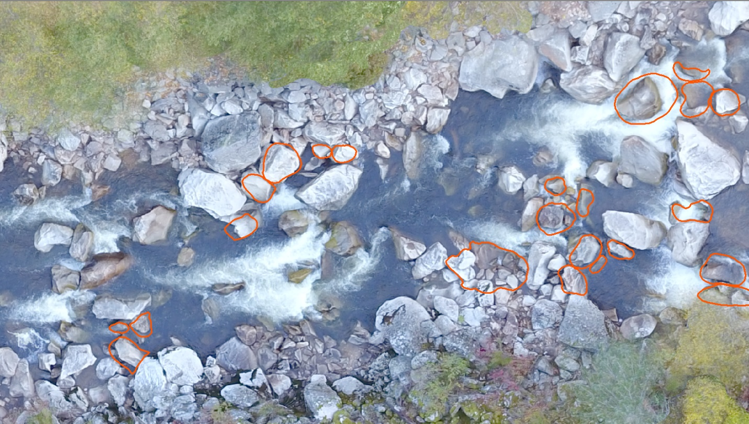

Figure 1: SF Clearwater aerial with boulders highlighted (orange) for removal as part of Alternative 1.

### Alternative 2

For Alternative 2, we reviewed the results from Alternative 1 and determined areas where more rock removal is likely to be beneficial. We also wanted to examine the effect of placing boulders in the channel. This is logistically a much more difficult process than rock removal, but worth exploring at this level of modeling. Figure 2 shows the boulders removed in Alternative 1 in orange, the additional rock removal for Alternative 2 in yellow, and rock additions in white.

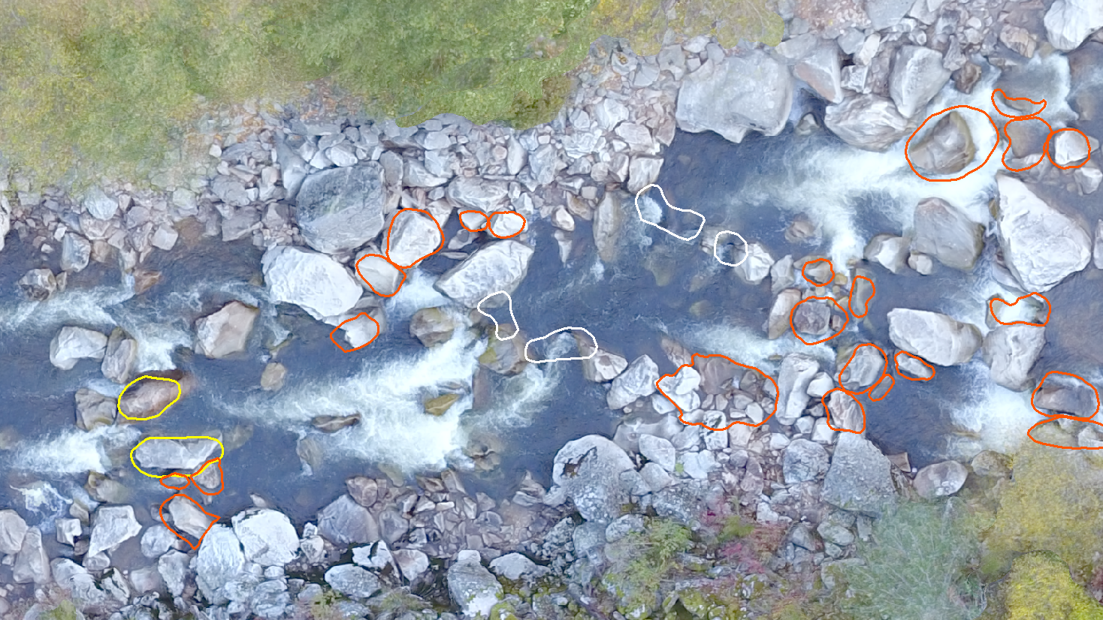

Figure 2: SF Clearwater aerial image with boulders from Alternative 1 (orange), additional boulder removal (yellow), and boulder placement (white).

# Results

The modeled alternatives show notable changes in hydraulic conditions in the study reach. While it is unlikely to remove all barriers, we see that boulder removal is capable of greatly reducing the velocities and/or providing additional routes of easier ascent. For example, in the area shown in Figure 3, under existing conditions three high velocity/low depth pathways are likely partial barriers or points of difficult passage for migratory fish.

By removing boulders, an entirely new pathway can be opened, which reduces velocities in the other slots, giving fish a variety of options, all of which are likely less taxing than what existed before. Figure 4 shows an area of the model where boulders were both added and removed. The changes in velocity are more subtle between Alternatives 1 and 2 than between either alternative and existing conditions, and benefits from adding rock appear less obvious.

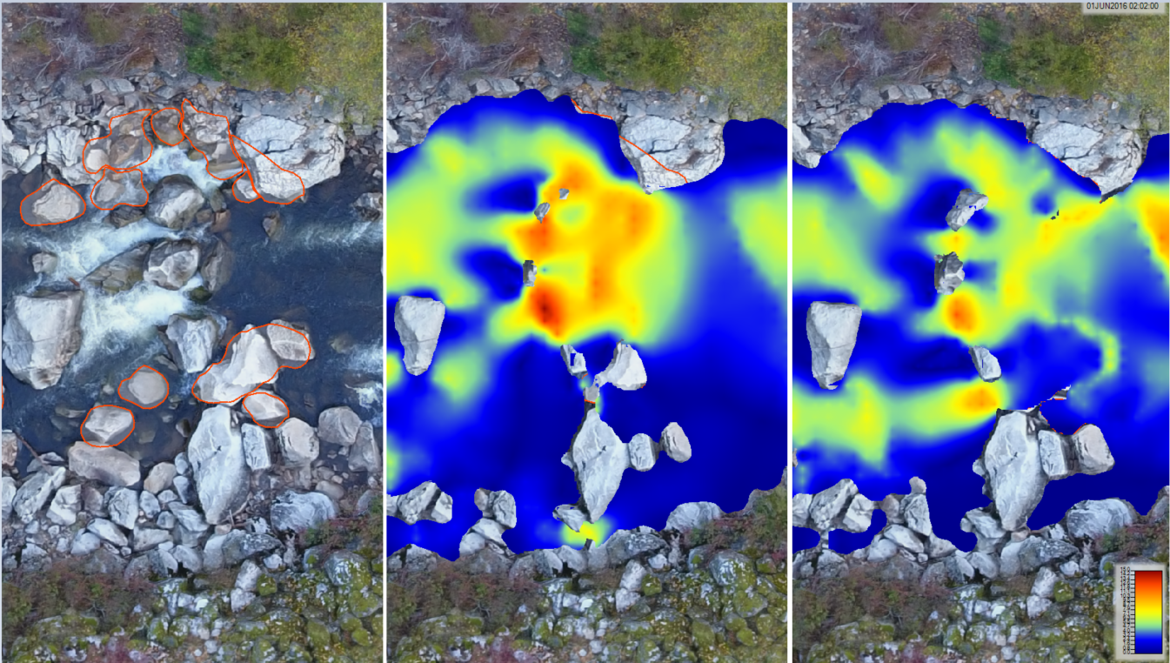

Figure 3: From left to right: aerial photo with boulders to be removed; existing conditions velocities at 700 cfs; Alternative 1 velocities at 700 cfs (right).

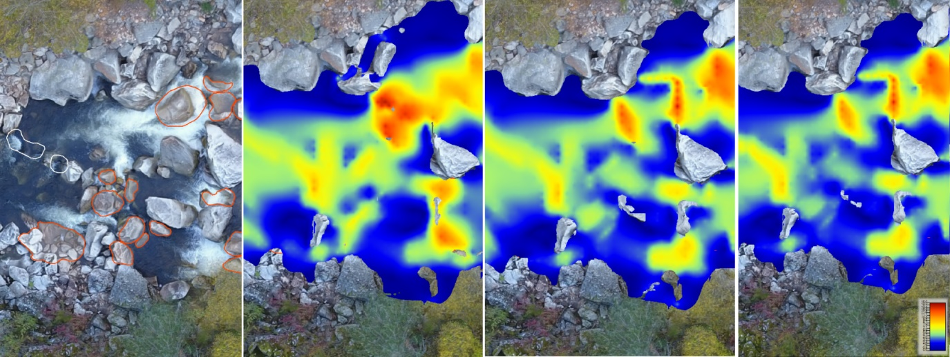

Figure 4: From left to right: aerial photo with boulders to be removed and added; existing conditions velocities at 700 cfs; Alternative 1 velocities, Alternative 2 velocities.

The entire HEC-RAS model is provided to CFS via the NHC share ftp site. Plans p.62 and p.63 are the Alternative 1 and 2 simulations, respectively. As in the previous model, Plan p.61 is the existing conditions simulation. Mp4 video files of the animated model simulation for depth and velocity from each alternative are located in the same ftp directory and archived at the following locations.

Alternative 1 Velocity: <https://vimeo.com/250877438>

Alternative 1 Depth: <https://vimeo.com/250877378>

Alternative 2 Velocity: <https://vimeo.com/250877580>

Alternative 2 Depth: <https://vimeo.com/250877647>

# Interpretation

Review of hydraulic model results and comparison with existing conditions show that there is potential to substantially alter the channel hydraulics over a broad range of flows by removing select boulders. Given the nature of the reach morphology and flow regime, where flow depth is equivalent to or smaller than the diameter of individual boulders, this is not surprising. In places, removing a single boulder can increase the effective flow cross-sectional area at low to moderate flows by a factor of two or more.

In contrast, addition of rock (at the scale evaluated here) appears to have very little influence on barrier hydraulics. This is because supercritical flow conditions, where downstream hydraulic influences do not propagate upstream, is typical at many of the barriers in this reach. Addition of rock to the channel downstream, therefore, does not tend to substantially modify hydraulics at barrier features. It may still be considered, however, to improve approach hydraulics if no rock breaking technique can achieve that goal at a given location.

NHC’s design strategy in selecting which boulders to remove has been described above, but it is important to hold in mind this strategy and process —and the limitations thereof— when interpreting model results. The modifications were designed to create one or more passable routes past identified barriers, not necessarily to erase their presence. In order to be efficient, the design process was not iterated, and so hydraulic results should not be viewed as the best possible fish passage improvement but an illustration of the magnitude of effect expected from targeted rock breaking activity.

Because of the goal to visualize whether passable routes are available, we recommend that CFS map both areas that are clearly passable and reasonable holding locations (exceed a reasonable threshold depth and do not exceed a reasonable endurance swimming velocity) and locations of barrier features for select flows.

# Conclusion and RECOMMENDATIONS

Results of this heuristic modeling exercise, our experience applying rock breaking strategies to improve fish passage and movement at other locations, and qualitative assessment of conditions at the MP 28 barrier lead us to believe that it would be clearly possible to substantially increase fish passage using selective rock breaking. This approach has proved to be cost-effective in other locations.

Some iteration of design and hydraulic modeling, which has not been done as a part of this phase of the project, may be necessary to show on paper that the approach will work and may be beneficial to optimize the design.

There is substantial uncertainty in the extent of overall channel response to boulder removal, but some shifting of adjacent and nearby boulders is to be expected following removal. Because of this uncertainty, the recommended approach to project implementation is to iterate construction with effectiveness monitoring until a performance benchmark is met —typically to develop both channel form and resolve specific hydraulic barriers.

In some instances, a multi-year effort is required, timing boulder and rock breaking with floods or freshets used to flush and restructure the channel. The sequencing of work allows for physical works during low water periods and effectiveness evaluation during open water. NHC recommends ongoing biological monitoring through snorkelling, tagging, or other applicable techniques to assess fish movement. The preferred, risk-adverse approach is iterative construction and observation of channel hydraulics and fish behavior.

Relative to other mitigation options available at these types of barriers, in situ rock removal costs are reasonable and provide a long-term, volitional, ”no touch” option that many fish passage options do not have. This method may be a preferred approach for fish stocks that may be generically-adapted to adverse hydraulic regimes as a selective mechanism, such as summer-run Steelhead.

If in situ rock removal is being considered as a potential fish passage mitigation option by the Tribe, additional recommendations include:

1. Further assessment of localized hydraulics during migrations flows, fine tuning of potential barriers and selected in situ rock to be altered or removed.
2. Developing a detailed work plan, outlining drilling sites, rock breakage objectives, and expected hydraulic outcomes for selected sites.
3. Discussion with federal and state agencies regarding in situ rock removal work, permitting and approval processes with relatively novel process and procedures.
4. Working with a rock scaling/breaking contractor to develop detailed work plan, costs, and construction safety and environmental management plan.

As we have been discussing throughout this project, there are value judgments remaining, however, as to whether the feature “should” be removed. We believe this modeling exercise has shown the magnitude of hydraulic change that is possible to impose on localized barrier features by a selective in situ rock breaking strategy appears to be adequate to create fish passable routes throughout the project area.

# **Closure**

We appreciate the opportunity to work with Cramer Fish Sciences and the Nez Perce Tribe on this critical fish passage issue on the South Fork Clearwater River. We hope our work furthers more investigation, and eventual mitigation of the issues for Steelhead in the system. If there are any questions or comments regarding our work, analyses, or results, please contact us. We are available to assist in any way.

Sincerely,

**Northwest Hydraulic Consultants Inc.**

|  |  |
| --- | --- |
| **Prepared by or under the direct supervision of:** | |
|  |  |
| Jaron Brown, M.S., P.E. | Barry Chilibeck, MASc, PEng |
| Hydraulic Engineer | Principal |
|  |  |
| Andrew Nelson, M.S., L.G. |  |
| Fluvial Geomorphologist |  |
|  |  |

DISCLAIMER

This document has been prepared by Northwest Hydraulic Consultants Inc. in accordance with generally accepted engineering practices and is intended for the exclusive use and benefit of Cramer Fish Sciences and the Nez Perce Tribe and their authorized representatives for specific application to the MP 28 Velocity Barrier evaluation project on the SF Clearwater River near Golden, ID. The contents of this document are not to be relied upon or used, in whole or in part, by or for the benefit of others without specific written authorization from Northwest Hydraulic Consultants Inc. No other warranty, expressed or implied, is made. Northwest Hydraulic Consultants Inc. and its officers, directors, employees, and agents assume no responsibility for the reliance upon this document or any of its contents by any parties other than Cramer Fish Sciences and the Nez Perce Tribe.